1)Databases in Server?
sp_helpdb

2)Listout datafiles & logfiles in db?
Syntax:sp_helpdb dbname
Ex:sp_helpdb salesotder

3)How to find out SQL Server Version Number & service pack?

a)select @@version
Microsoft SQL Server 2005 - 9.00.1399.06 (Intel X86) Oct 14 2005 00:33:37 Copyright (c) 1988-2005 Microsoft Corporation Standard Edition on Windows NT 5.1 (Build 2600: Service Pack 2)

b) select serverproperty('productlevel')
RTM,SP1,SP2,SP3,SP4

4) Database Creation?
create database salesorder
on
(name=salesorder,
filename='D:\Vinay\temp\salesorder.mdf',
size=5mb,
maxsize=10mb,
filegrowth=1mb
)
log on
(
name=salesorder_log,
filename='D:\Vinay\temp\salesorder_log.ldf',
size=5mb,
maxsize=10mb,
filegrowth=1mb
)

5)Alter Database?
Alter database is nothing but modifing the structure of exicting database.

Syntax:
Alter database database name
Add file(datafile specification)
Add logfile(logfile specification)
Modify file(newfile specification)
Remove file(logical Name)

i) Adding data file(means ndf file):
alter database salesorder
add file
(
name=salesorder_n,
filename='D:\Vinay\temp\salesorder_n.ndf',
size=2mb,
maxsize=5mb,
filegrowth=1mb
)
Adding log file:

ii) Mogifing data & log file:
alter database salesorder
modify file
(
name=salesorder_n,
filename='D:\Vinay\temp\salesorder_n.ndf',
size=10mb,
maxsize=15mb,
filegrowth=1mb
)
The file "salesorder_n" has been modified in the system catalog. The new path will be used the next time the database is started.

iii) Removing data & log file:
******The primary data or log file cannot be removed from a database.

Syntax: alter database dbname
remove file name
Ex:
alter database salesorder
remove file salesorder_n

The file 'salesorder_n' has been removed.

iv) Renaming the database:
****Whenever your enter into new dbname is word to word space is not correct,you can use ‘_’ .

Syntax: alter database dbname
modify name =new dbname
Ex:
alter database salesorder
modify name =salesorder_info

The database name 'salesorder_info' has been set.

v) Droping the database:
*** Drop the entire database

Syntax: drop database dbname

Ex:
drop database nani

6)DBCC Commands?

- DBCC SQLPERF(logspace):

Displays LOGSPACE information for all databases contained in the instance of SQL Server

Db name logsize(MB)Log spaceused(%) status
master 1.242188 42.45283 0
tempdb 0.4921875 63.88889 0
model 0.9921875 55.90551 0
msdb 1.992188 33.92157 0
testing 0.9921875 47.53937 0

DBCC SQLPERF(WAITSTATS):

Wait_type request waittime signal_waittime
MISCELLANEOUS 4 609 0
LCK_M_SCH_S 0 0 0
LCK_M_SCH_M 0 0 0
LCK_M_S 1 2250 0
LCK_M_U 0 0 0
LCK_M_X 0 0 0
LCK_M_IS 0 0 0
LCK_M_IU 0 0 0
LCK_M_IX 0 0 0
LCK_M_SIU 0 0 0

- DBCC SHOWCONTIG: showconfig is displays the number of pages, extents in the table or index.

Syntax:
DBCC SHOWCONTIG
[ (
{ table_name | table_id | view_name | view_id }
[ , index_name | index_id ]
) ]
[ WITH
{
[ , [ ALL_INDEXES ] ]
[ , [ TABLERESULTS ] ]
[ , [ FAST ] ]
[ , [ ALL_LEVELS ] ]
[ NO_INFOMSGS ]
}
]

DBCC SHOWCONTIG(tablename)

i)displays fragmentation information for the student table?
DBCC SHOWCONTIG('Student')

DBCC SHOWCONTIG scanning 'Student' table...
Table: 'Student' (2121058592); index ID: 0, database ID: 5
TABLE level scan performed.
- Pages Scanned................................: 1
- Extents Scanned..............................: 1
- Extent Switches..............................: 0
- Avg. Pages per Extent........................: 1.0
- Scan Density [Best Count:Actual Count].......: 100.00% [1:1]
- Extent Scan Fragmentation ...................: 0.00%
- Avg. Bytes Free per Page.....................: 8033.0
- Avg. Page Density (full).....................: 0.75%
DBCC execution completed. If DBCC printed error messages, contact your system administrator.

Security:
1: Displaying all users in the database?
exec sp_helpuser

2: Displaying information on one user?
exec sp_helpuser 'sys'

3: Displaying all user members of a role?
exec sp_helpuser 'db_owner'

4: Returning a list of all fixed server roles?
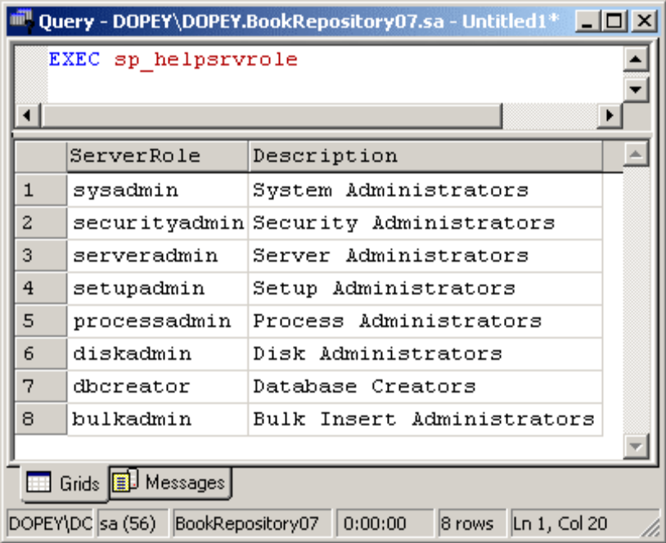

5. Returning all permissions for all fixed server roles?
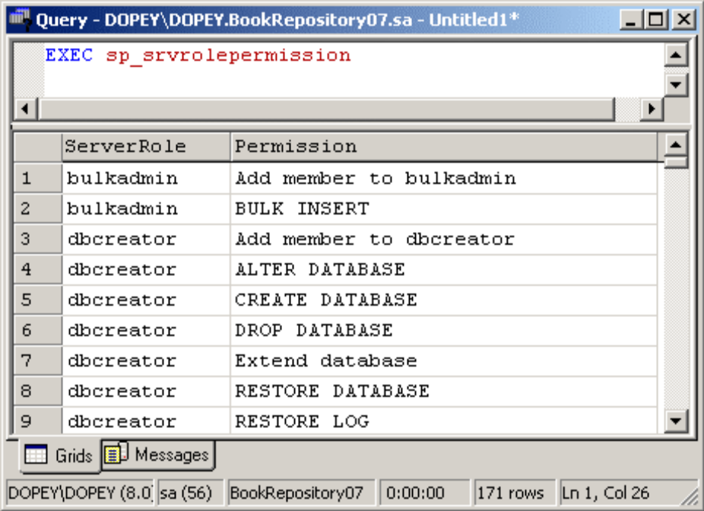

How to database emegergency mode to single user mode?

Step1)Database emegergency mode to single user mode
ALTER DATABASE Vin SET Single_USER
GO
DBCC CHECKDB ('Vin', REPAIR_ALLOW_DATA_LOSS)

Step2)After Database single user mode to multi user mode
ALTER DATABASE Vin SET MULTI_USER

How to database emergency mode?

ALTER DATABASE Vin SET EMERGENCY

